

Basic Formal Analysis of Photographs

INSTRUCTOR VERSION

Introduction
Visual media affects all of our lives, across culture and class, in terms of how we view the world in every discipline, from medicine to music; from astronomy to criminal justice. Images and media also allow us an outlet to our personal lives in how we record family, events and time passing.

In order to be visually literate, and in addition to the practices of data collection, data design, and writing, it’s imperative that students are able to observe, deconstruct, critique and effectively utilize images to accompany academic research that works toward an understanding of the problems we face.

This module will allow for students to be able to develop a visual vocabulary for discussing photographic images and to visually deconstruct them using ten specific visual tools.

Student Learning Outcomes:

- Establish a basic vocabulary for talking about images, increasing students’ visual literacy.
- Effectively apply this vocabulary to specific images.
- Critique examples of images that involve subject matter related to race and class
- Communicate complex ideas, problems or issues effectively and efficiently through the strategic use of images.
- Demonstrate proficiency with deconstruction of a single or series of images.

PART I: Basic Primer on Formal Aspects of Images:

Basic Strategies in Reading Photographs: http://nuovo.com/southern-images/analyses.html
Image source: https://www.christies.com/lotfinder/Lot/henri-cartierbresson-19082004-rue-mouffetard-paris-1954-6018122-details.aspx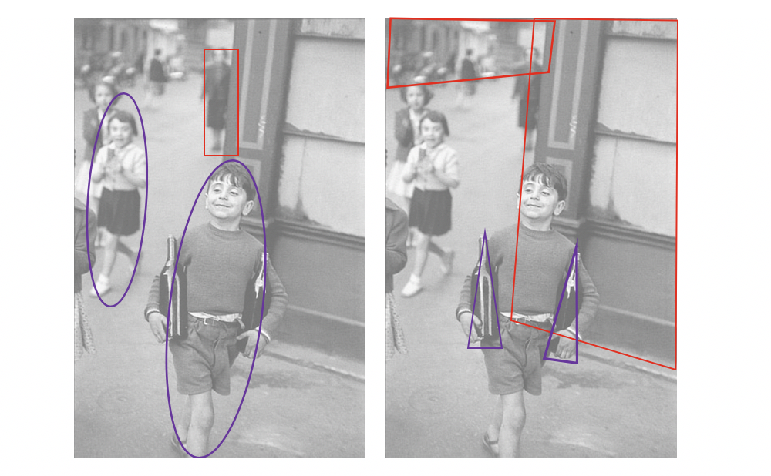

- Line:
  - Why is it important in any image?

Lines can lead our eye, sometimes subconsciously. Are there objects in the photograph that act as lines? Are they straight, curvy, thin, thick? Do the lines create direction in the photograph? Do they outline? Do the lines express movement or energy?

  - Why is it important in this image?

The lines of the building behind the boy lead our eyes to his head, neck shoulders and hands, framing his body in a very purposeful way. The lines also lead us to the other children, who act as supporting characters, and are reacting to him. They make the image more complex, and refer to the boy’s performing, rather than just his state of pride while carrying the bottles of wine.

- Shape: organic vs. geometric – simple rectilinear or curvilinear shapes found in geometry, such as circles, squares, triangles, etc.

  - Why is it important in any image?

Shapes are some of our earliest learning tools, describing what brings balance or imbalance to the physical world, as well as the differentiation between the organic world and the artificial.

  - Why is it important in this image?

There are distinct contrasts between the figures’ organic shapes (most notably, the children’s) and the harder, more geometric shapes of the architecture. We might also note that the wine bottles, although artificially made, have more organic shapes and reflections, while the figure of the woman in the background has more rectilinear shapes compared to the children.

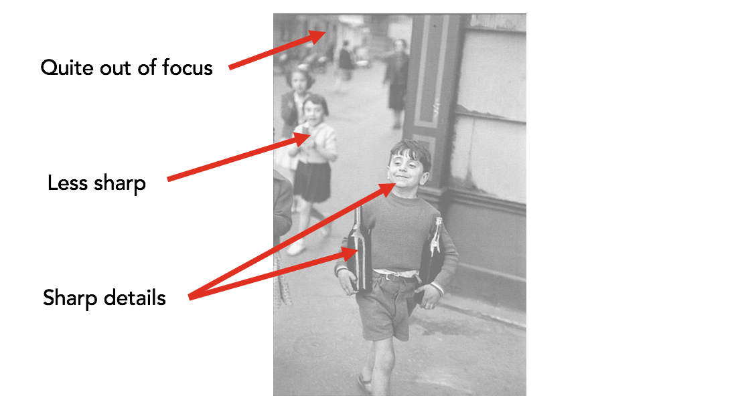
- Depth of Field/Focus: what areas appear clearest or sharpest in the photograph? What do not?

  - Why is it important in any image?
Cameras have the ability to record a range of what planes of focus are sharp. This range is called the Depth of Field of an image. Several factors influence depth of field including the amount of light, the camera’s aperture setting (how wide or narrow is the opening that allows light into the camera itself) as well as how close the photographer is to the subject. A smaller aperture (larger number) will result in a deeper depth of field, which a larger aperture (smaller number) will result in a more shallow depth of field (see example below).

  - Why is it important in this image?
This image has relatively narrow depth of field, as the camera was focused on the boy as he moved toward the photographer. The other figures and background get gradually more out of focus as the space recedes. As humans are used to areas of sharpness (our eyes do this reflexively with the retinal system), we might be more attracted to the areas of the photograph that are sharp. However, the areas that are not sharp allow for this contrast to occur, thus highlighting some areas over others.
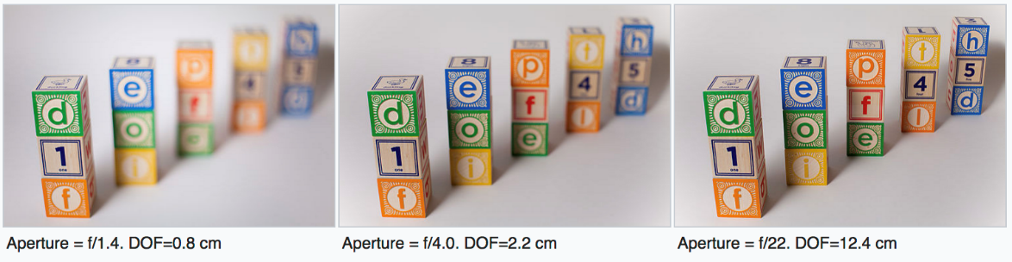
Source: Wikipedia (http://www.photoskop.com/player.html?l=all&ch=3&sec=0)
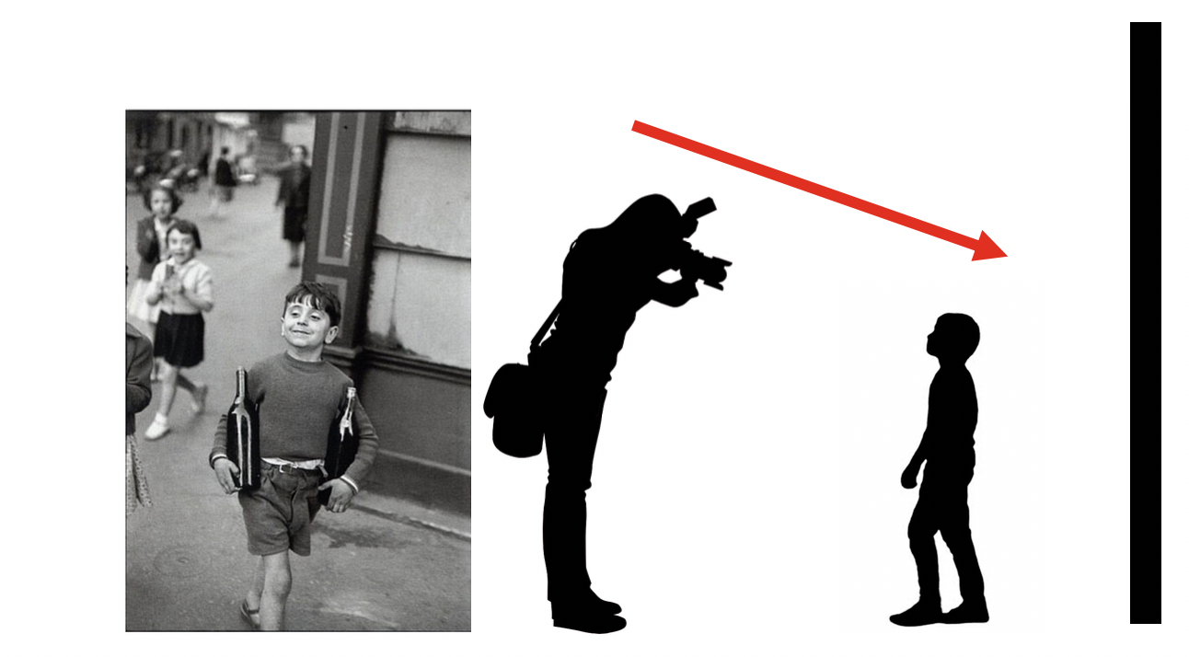
- Vantage Point: the place from which a photographer takes a photograph.

  - Why is it important in any image?

Vantage point can (a) allow the viewer to see more or less of an image, and (b) amplify or reduce the angle with which we see the subject. The vantage point also implies visual power/positioning, as a photographer that was literally above the subject has a more imposing position than one where the photographer is at equal height or below the subject.

  - Why is it important in this image?

The angle allows the photographer to position the child’s body in reference to the group, the building, and the other children. The moment is remarkable, as the angle not only allows for scaling between the different figures, but also positions the child at the crux of the building’s foundation. The vantage point also gives the viewer a (literally) heightened sense that this is from the viewpoint of an adult, looking at a smaller person.

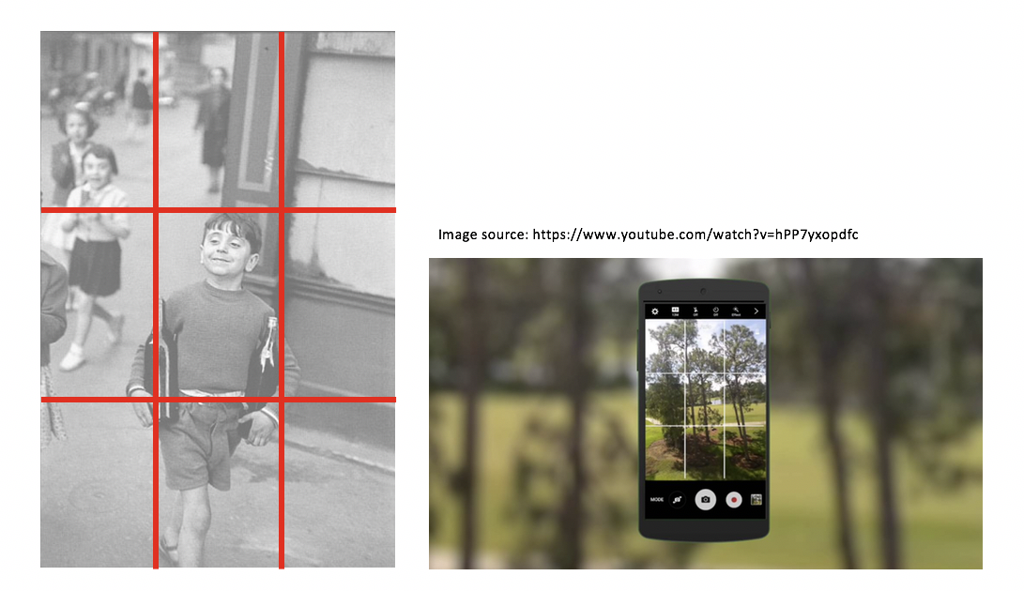
- Three Thirds Rule: a standard division of the frame into nine equal parts that helps photographers place/weight objects within their images as compared to other objects in the same scene.

  - Why is it important in any image?

From older analog cameras to motion picture cameras to smartphones, this is an international standard of space arrangement within a frame that allows the recorder to think in real time about where key elements are placed, and the weight each element has within the frame. Photographers/videographers often consider the points at which the lines intersect as key point where visual information might be weighted.

  - Why is it important in this image?

The photographer of this particular image, Henri Cartier-Bresson was a master of timing (what he termed “the decisive moment” of taking the image) and placing his subjects within the frame. We can see how the main subject is framed within the middle grid frame, adding geometric emphasis to his presence. We can also see how the two wine bottles fall near the bottom two intersect points, and the adult in the background is placed dead center in the top-middle section.
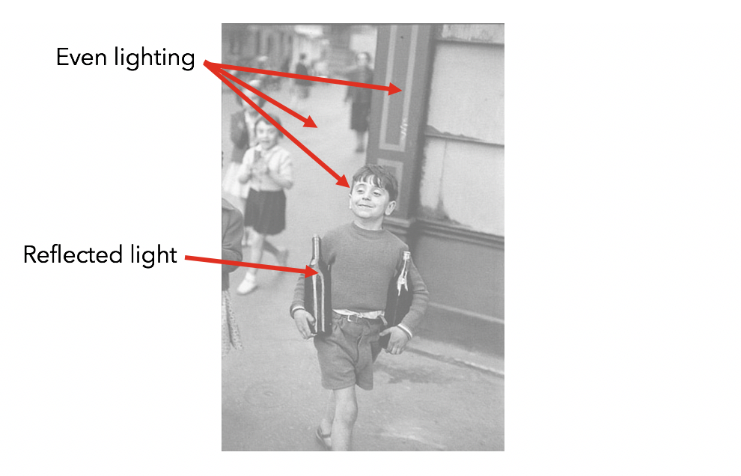
- Light: what areas of the photograph are most highlighted? Does the photograph allow you to guess the time of day? Is the light natural or artificial? Hard or soft? Reflected or direct?

  - Why is it important in any image?

Light can be complementary to the subject, or, under certain conditions, hinder information (in the form of dark shadows or over-exposed highlights. Light also might render a subject so it is more visible than the rest of the image. Light can lead our eye through an image, or add emotional impact, depending on how it is found or used.

  - Why is it important in this image?

In the Bresson image, the light seems to be coming from behind the photographer, and the soft shadows hint at an overcast day. The overall lighting is fairly even, equalizing the importance of the different people and elements. One exception is the dramatic reflections of the wine bottle, which immediately tell the viewer what the objects might be made of, adding meaning to their shapes and role in the image’s story.

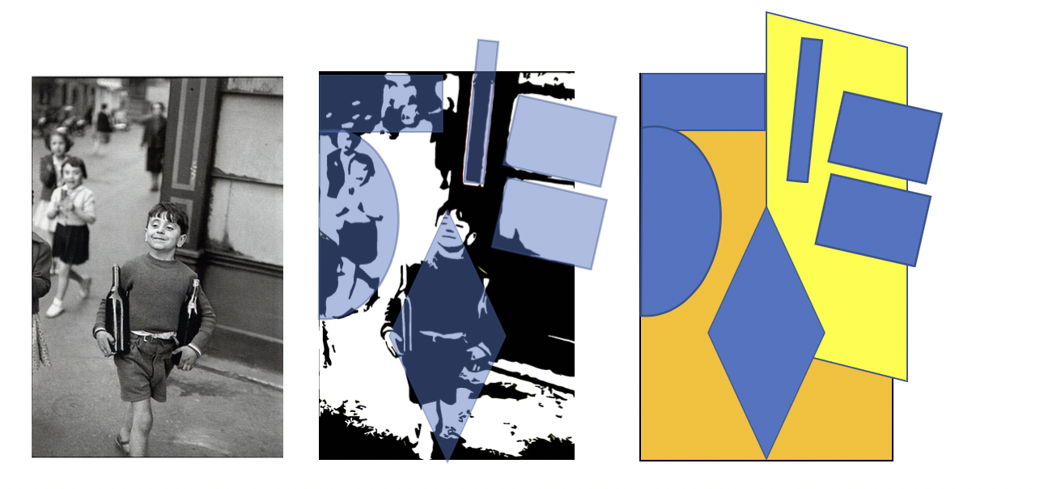
- Composition/Balance: the arrangement or structure of the formal elements that make up an image and how they are weighted within the frame.

  - Why is it important in any image?

Composition makes up the geometric balance within the image, establishing visual weight, and the range of balanced elements (often more evident in landscapes) vs unbalanced (as is sometimes seen in photojournalism.)

Symmetrical balance distributes visual elements evenly in an image. Asymmetrical balance is found when visual elements are not evenly distributed in an image.

  - Why is it important in this image?

After breaking up into its primary visual elements, we can see this image has a weight of shapes in the upper left hand corner as well as a variety of geometry, allowing the image to be somewhat dynamic and visually unstable.

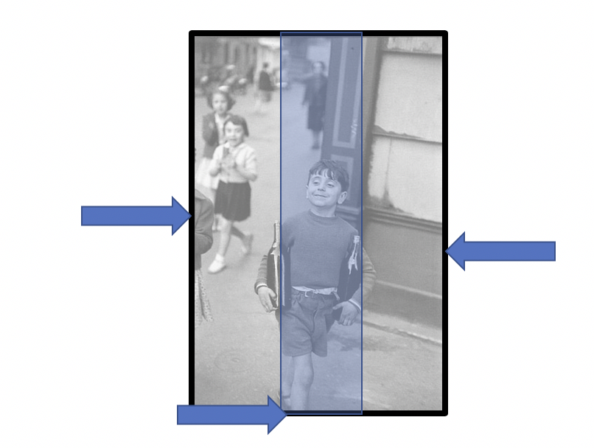

- Framing: what the photographer has placed within the boundaries of the photograph and establishes what is, and isn’t included in the frame.

  - Why is it important in any image?
Framing is an in-the-moment editing tool that immediate determine where the viewer is looking and what they will see. Tight framing can add tension or even mystery to an image, and challenge the viewer to question what wasn’t included (and perhaps should have been).

Cropping (after the image is taken) is an important visual tool that can eliminate information to make an image stronger. Cropping can also be controversial, as was the image of a child victim after the Oklahoma City bombings in 1995 (see below).

  - Why is it important in this image?
The framing helps establish the central focus of the image, the objects(s) which appear(s) most prominently in a photograph. In this case, it’s the boy placed in the lower center, aligned with the out-of-focus adult in the back. The framing also allowed for his foot to be cut off, suggesting that he had space to move into, as well as suggesting he was moving so quickly he couldn’t be captured completely! The framing also allowed for some elements to be pushed to the edge or completely off, such as the girls on the left hand side and the building itself.

Assignment #1:

Apply the above terms and ideas to the following image by Robert Frank. Divide students into groups and task each group with 2-3 of the above formal analysis tools. Ask students to write down how they are specifically relating the term to the image below.

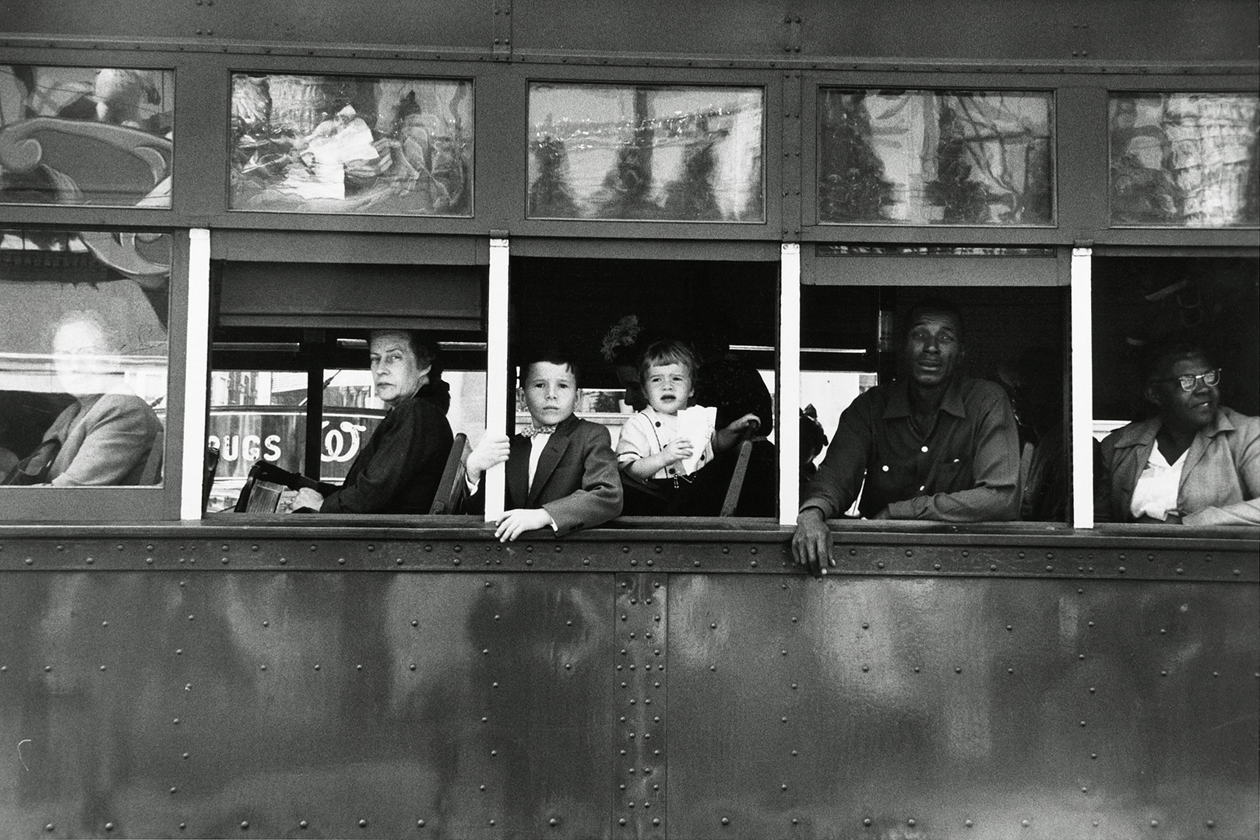

Trolley – New Orleans, 1955
Image source: http://100photos.time.com/photos/robert-frank-trolley-new-orleans

Assignment #2:

A second stage of inquiry is to ask the students to list how important each of these 8 formal elements are, and to rank them in order of importance as they pertain to the image. (You might even consider leaving the room while they rank these, to give them some agency/power without the authority figure in the room.)

Once they are ranked, ask the students to explain why the top three terms were chosen. Why are these three more important than the other? Was there a disagreement? After the discussion, have they changed their minds?

One variation is to ask a second group to listen carefully to the first group to see if they are communicating their ideas correctly. A person from the second group can physically be near the image’s projection and help point out what it is the first group is describing.

- Intention: reason(s) why the photographer made an image
Other than concrete visual elements, any image should be considered for its content. Establishing meaning is multi-layered, but is a vital part of visual literacy. One place we can start is to discuss intent. Why do you think this photographer took this photograph in the first place? Was it to entertain? To document? To inform? Was it to capture a news story, to back up other data-driven information, or was it for aesthetic reasons?
Perhaps Bresson was celebrating the child’s joy, as well as his taking a moment to perform a task that is usually reserved for adults (carrying not one, but two bottles of wine!) We might also perform some research on the image and its photographer, to put both in context.

Assignment #3:
Ask students to write two paragraphs deciding what they think both Bresson and Frank’s intentions were in making their respective images. After groups have defended their views, ask them to research on phones or laptops the history of each image.

- Signs (Signifier/Signified)
A more sophisticated way to assess an image (or any visual – even typography) is to examine basic visual elements and to determine their meanings through signs. Signs might offer hints at culture, location, and historical timeframe.

Assignment #4:
Ask students to examine the signs circled in the images. What are they literally? Why are they important as visual anchors? What do they imply/symbolize?
